English title (Times New Roman 12pt Bold)

First Author¹, Times New Roman 10pt² and Third Author²
¹Affiliation of First Author (Times New Roman 10 pt Italic)
²Affiliation of Second and Third Authors

This document shows a sample abstract format (except for Antarctic Meteorite session). English abstract is required. Abstract should be no longer than two pages on A4 sheet including figures, tables and references. Line spacing is fixed with14 pt. Font used in text is Times New Roman 10 pt. Please set top and bottom margin as 2 cm, and right and left margin as 1.5 cm. PDF file of the abstract is only accepted for the submission, please convert MS-word or the other file format to PDF file before the abstract submission by yourself. Please also rename your abstract pdf file to SC_FamilynameFirstname_N(_v?).pdf (where SC is the session code (among S, IA, IC, IM, IP, OS, OM, OG, OB) which you selected as your 1st choice; N is the order of your submission (normally 1); if this is your revised version, add _v? at the end before the file extension .pdf as a version number (say, _v2, _v3, etc) ) Please note that the abstracts will be open to the public via this symposium web site, please pay attention for making your abstract including the figures and tables. If you do not have Adobe Acrobat to make a pdf file, there are several ways to convert a file to pdf format, refer to, e.g.,
http://wiki.openoffice.org/wiki/Documentation/OOo3_User_Guides/Getting_Started/Exporting_to_PDF
http://www.primopdf.com/ http://www.pdfforge.org/pdfcreator
See http://www.nipr.ac.jp/symposium2014/e/ for more details.

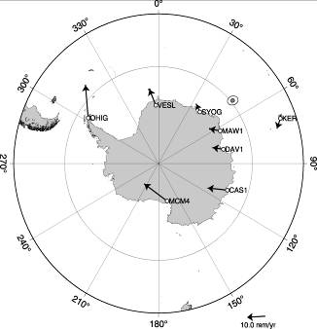

Table 1. Table font size 9 pt.
X | Y | Z
1 | 2 | 3
0.1 | 0.2 | 0.3

Figure 1. Figure font size is also 9pt.

References
Kawamura, K. and T.F. Stocker, High-resolution carbon dioxide concentration record 650,000-800,000 years before present, Nature, 453(7193), 379-382 , 2008.

