Title (Times New Roman 12pt Bold)

First Author¹, Times New Roman 10pt² and Third Author²
¹Affiliation of First Author (Times New Roman 10 pt Italic)
²Affiliation of Second and Third Authors

This template shows a abstract format. The abstract should be a PDF file of no longer than two pages on an A4 sheet, including figures, tables, and references. File size including tables and figures must be smaller than 10MB in PDF. Line spacing is fixed with 14 pt. Font used in text is Times New Roman 10 pt. Please set top and bottom margin as 20 mm, and right and left margin as 15 mm.
Please convert MS-word or the other file format to PDF format before the abstract submission by yourself. Your abstract pdf file can have an arbitrary name. If you do not have software to convert your documents to PDF files, there are several ways to do so, even via free software such as OpenOffice, PrimoPDF, and PDFCreator.
http://wiki.openoffice.org/wiki/Documentation/OOo3_User_Guides/Getting_Started/Exporting_to_PDF
http://www.primopdf.com/
http://www.pdfforge.org/pdfcreator
Note: The copyright of the abstract belongs to the authors. Please note that Local Organizing Committee (LOC) of the Tenth Symposium on Polar Science has a right to publish the Abstract on the National Institute of Polar Research Information Repository (NIPR repository) website. Please read the operating guideline of the repository and continue to register only if you agree to the guideline. NIPR can distribute the abstract as a booklet or a recording medium.
The abstract is appropriately discarded in response to authors' request.
See http://www.nipr.ac.jp/symposium2019 for more details.

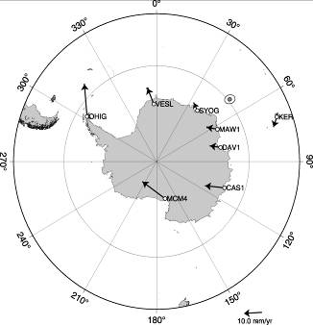

Table 1. Table font size 9 pt.
X | Y | Z
1 | 2 | 3
0.1 | 0.2 | 0.3

Figure 1. Figure font size is also 9pt.

References
Kawamura, K. and T.F. Stocker, High-resolution carbon dioxide concentration record 650,000-800,000 years before present, Nature, 453(7193), 379-382 , 2008.

