Title (Times New Roman 12pt Bold)

First Author¹(Please underline the presenting author), Times New Roman 11pt² and Third Author²
¹Affiliation of First Author (Times New Roman 11 pt Italic)
²Affiliation of Second and Third Authors

This template shows an abstract format. The abstract should be a PDF file of no longer than two pages on an A4 sheet, including figures, tables, and references. File size, including tables and figures, must be smaller than 10MB in PDF format. Line spacing is fixed with 15 pt. The font used in the text is Times New Roman 11 pt. Please set the top and bottom margins as 20 mm and the right and left margins as 15 mm.
Please convert MS Word or another file format to PDF format before you submit the abstract. Your abstract PDF file can have an arbitrary name. If you do not have software to convert your documents to PDF files, there are several ways to do so, even via free software such as OpenOffice.
(http://wiki.openoffice.org/wiki/Documentation/OOo3_User_Guides/Getting_Started/Exporting_to_PDF)
Note: The copyright of the abstract belongs to the authors. Please note that the Executive Committee (EC) of the Symposium on Polar Science has the right to publish the abstract on the National Institute of Polar Research Information Repository (NIPR repository) website. Please read the operating guidelines of the repository and continue to register if you agree to the guidelines. NIPR can distribute the abstract as a booklet or a recording medium.
The abstract is appropriately discarded in response to the authors' request.

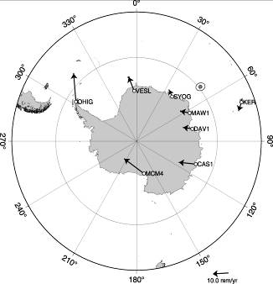

Table 1. Table font size 10 pt.
X | Y | Z
1 | 2 | 3
0.1 | 0.2 | 0.3

Figure 1. The figure font size is also 10pt.

References
Anderson KR, Jones ML, Allison IS, A major ecosystem shift in the Barents Sea. Polar Nature, 45, 37-42, 2024.
Gosin AA, Marty L, Gibson N et al., Lichens around Syowa Station in Antarctica. Journal of Polar Environment, 12.5280/polareco.20814373, 2021.

